**Project Design Phase-I**

**Solution Architecture**

|  |  |
| --- | --- |
| Date | 21.10.2022 |
| Project Name | IOT Based Safety Gadget For Child Safety Monitoring &Notification |
| Maximum Mark | 4 marks |

**Solution Architecture:**

Solution architecture is a complex process – with many sub-processes – that bridges the gap between business problems and technology solutions. Its goals are to:

• Find the best tech solution to solve existing business problems.

• Describe the structure, characteristics, behaviour, and other aspects of the software to project stakeholders.

• Define features, development phases, and solution requirements.

• Provide specifications according to which the solution is defined, managed, and delivered.

**Solution Architecture Diagram:**

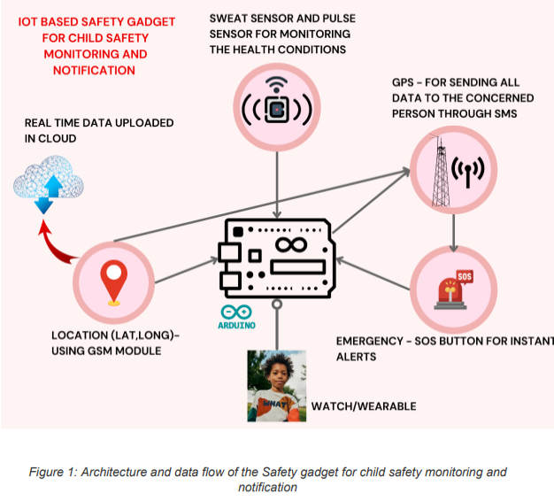

**AIM:**

To Provide Safety for children and monitor them using the gadget, Hence a wearable is designed with the following modules in order to satisfy the condition.

**MODULES INCLUDED:**

✓ ARDUINO UNO R3

✓ GSM SIM 900A

✓ GPS NEO 6M

✓ ESP32 (IoT)

✓ PULSE SENSOR

✓ SWEAT SENSOR

✓ SOS BUTTON

✓ BATTERY PACK

**FLOW OF THE ARCHITECHURE:**

✓ Controller plays the major role it controls all the modules used

✓ All the modules will be connected to the controller hence Arduino UNO R3

✓ For Powering the modules and controller, Battery pack can be used as it is carriable

✓ GPS module will constantly fetch the longitudes and latitudes (Coordinates) and will update in the cloud using ESP-32 .

✓ Sweat and Pulse sensor will constantly monitor the conditions, will send the data to the controller and cloud and if it exceeds the threshold that is already set then the controller will act on it by sending a SOS alert to the concerned members along with the GPS co-ordinates

✓ On Emergency situations, If SOS button is pressed then the controller will send the alert message along with the GPS Coordinates to the concerned members using GSM Module